

**Kazakh British Technical University**

**Report on industrial internship**

**Internship Supervisor:** Aryngazy Dastan

**Prepared by**: Zhamankhan Alikhan

20B030297, School of Information Technology and Engineering, Information Systems

**Contents**

**Introduction** 3

**1.** **General Characteristics of "Halik-Life" JSC** 4

**1.1.** **Information about "Halik-Life" JSC** 4

**1.2.** **Description of the Enterprise's Structure and Functions of Its Departments** 5

**1.3 Computational and Software Complexes of the Enterprise** 7

**2.** **Completed tasks during the internship** 8

**Conclusions** 11

**Offers** 11

**Bibilography** 12

# **Introduction**

Industrial internship is an essential stage in developing the required competencies among students. The aim of the internship is to solidify the theoretical knowledge acquired through practical participation in the activities of enterprises, gain professional skills and experience in independent work, especially in data analysis, as well as apply the acquired knowledge in practice.

In line with the set objectives, the following tasks are addressed:

* Attend an instructional meeting with the internship supervisor to clarify the contact details of the internship's line manager within the organization, as well as rules regarding subordination, appearance, work schedule, and safety techniques.
* Familiarize oneself with the enterprise: its type, specialization, location, and operating hours.
* Study the organizational structure of product development and business process management, and the functional responsibilities of employees.
* Study the preparation of reports from the supervisor.
* Participation in company projects.
* Processing and analysis of the acquired information.

The internship was at "Halik-Life" JSC, 109v Abaya Street, Multifunctional Complex Globus, Almaty.

# **General Characteristics of "Halik-Life" JSC**

* 1. **Information about "Halik-Life" JSC**

"Halik-Life" JSC, a subsidiary of the People's Bank of Kazakhstan for life insurance, was founded in November 2005. It is a subsidiary organization of one of the leading banks in the country, "People's Bank of Kazakhstan," which remains a systemically important bank in the country and owns 100% of the Company's shares.

Throughout its existence, the Company has firmly established itself among the leaders in life insurance companies operating in the Republic of Kazakhstan. Today, "Halik-Life" JSC offers a wide range of life insurance programs with conditions tailored individually for each client. These programs allow insuring life against specific events and, in addition to insurance protection, enable clients to accumulate savings for specific goals within a set timeframe.

At present, the company is actively developing its digitalization and automation systems, including the development of a mobile application that will enhance the customer journey. The company is moving towards a future where clients will not have to go anywhere from signing contracts to receiving profits; everything will be done online. To achieve this, the company uses government services, which leads to a leap in process automation. For document signing, biometric data reading services are used, ensuring 100% data integrity.

As for the Company's achievements, the international rating agency S&P Global Ratings has assigned a long-term financial stability rating to "Halik-Life" JSC at the level of "BBB-" and a rating on the Kazakh national scale of "kzAAA." The rating outlook is "Stable."

The Company holds a financial stability rating at the level of "B++" and a credit rating at the level of "bbb," which is the highest among all Kazakhstani life insurance companies, according to the international rating agency AM Best. The rating outlooks are "Stable."

The best assessment of "Halik-Life" JSC's activities remains the trust of its clients, whose number is growing every day, comprising 35% of the insurance market.

* 1. **Description of the Enterprise's Structure and Functions of Its Departments**

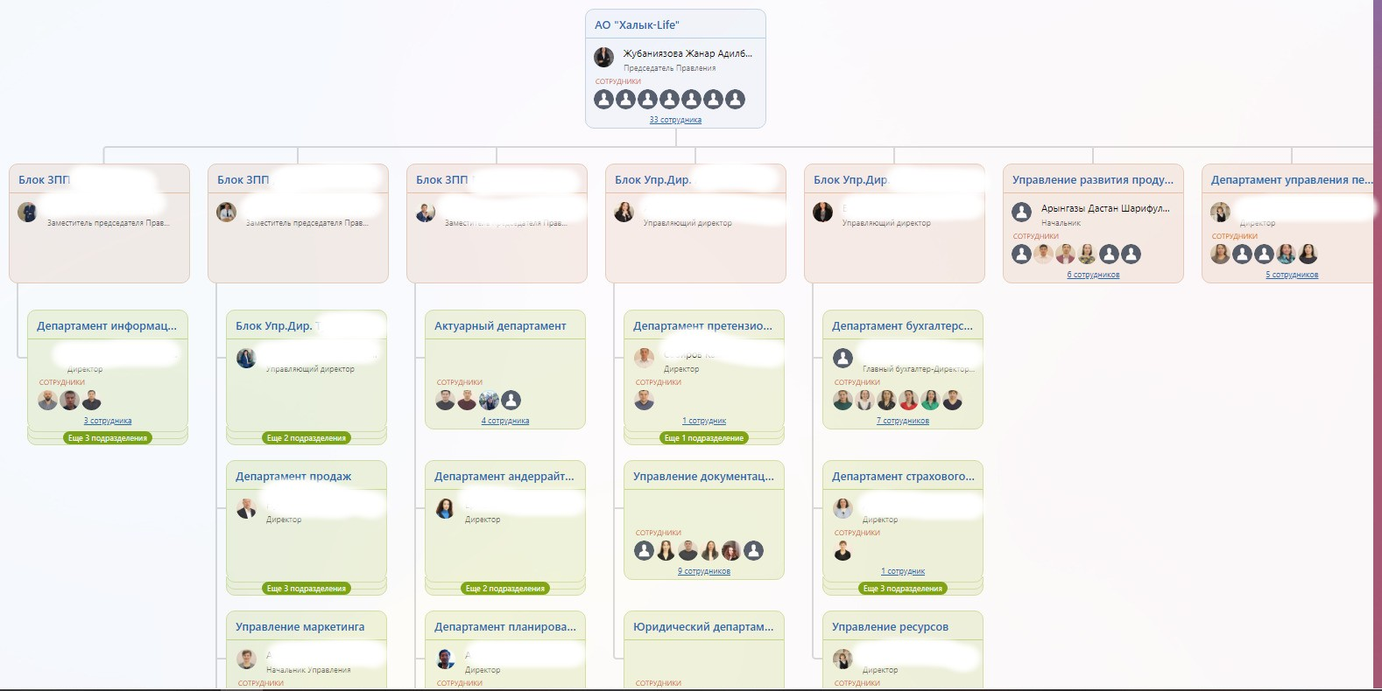

Zhunbayazova Zhannar Adilbekovna is the supervisor of the department where I completed my internship. The Product Development and Business Process Management Department is responsible for developing products, moving products into the online environment, automating back-office processes, and managing the company's documentation. Currently, they are actively working on the development of a mobile application and transitioning products to HomeBank.

The Deputy Chairman of the Board, **Aidos Serikovich Bekov**, oversees the development of tasks originating from the analytics department. Specifically, there is a restructuring of systems to integrate all products into a system based on Camunda.

The responsibilities of the Chairman of the Board include:

1. Possessing the knowledge, necessary and sufficient for proper participation in the work of the Board, in matters of financial and economic and production and economic activities of the Company established by the law of the Republic of Kazakhstan "On Insurance Activity" for persons intended for appointment or election to the position of a managerial employee of an insurance (reinsurance) organization (taking into account the feature provided for in paragraph 8 of this instruction).
2. Possessing knowledge of the legislation of the Republic of Kazakhstan on insurance and insurance activities, as well as on joint-stock companies.
3. Having skills in:

Economic analysis, planning, and forecasting, data summarization, and reporting.

Development (preparation) of normative and/or legal regulatory documents, methodological, methodical, analytical, and presentation materials.

Personnel management and organization of work in a team.

Working on a computer and the equipment used.

Other skills necessary for the proper performance of their job duties.

1. Personally and conscientiously perform work (labor function) in accordance with the job (functional) duties defined by this instruction, using methods that best serve the interests of the Company and its sole shareholder.
2. Adhere to labor and executive discipline.

The Product Development and Business Process Management department functions as a team with the goal of automating the Company's processes and optimizing back-office operations. The analytics team utilizes the latest technologies to enhance customer convenience and maintain a robust database. The department also regulates processes, drafts standard operating procedures, monitors printed forms used in the company, and ensures the execution of tasks, testing of new processes, diagramming processes, and setting deadlines.

The Product Development and Business Process Management department, where I completed my internship, is relatively new, having been in operation for less than two years. In this short time, the Company has confidently stepped into the future by automating its processes and making efforts to enhance customer convenience.

## **1.3 Computational and Software Complexes of the Enterprise**

In the office, each employee has a computer. All computers have the same specifications:

* Operating System: Windows 10 Pro
* Processor: Intel Core i5-4570 3.20 GHz
* Graphics Card: Nvidia Geforce GT 630
* RAM: 16 GB

The monitors are different for each computer.

All computers in the office are connected to a local network through a switch. Additionally, all office computers are connected to a printer via the network

1. **Completed tasks during the internship**

Individual assignment: Familiarize oneself with the company's database and carry out tasks assigned by the supervisor. During the internship, I worked with databases and created reports.

Below is a diagram of the database that I became acquainted with

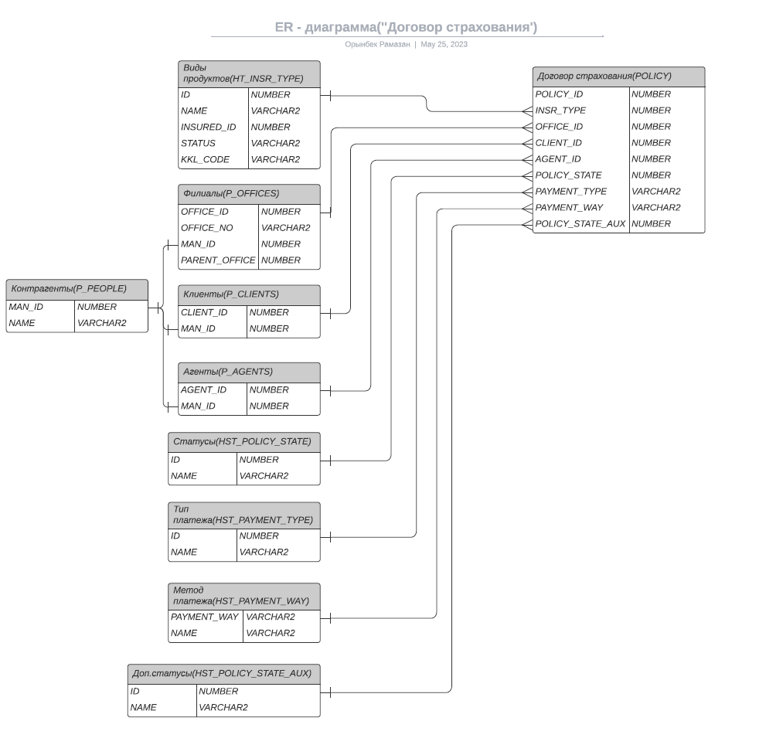

PL/SQL Developer is an integrated development environment (IDE) and client program designed for working with Oracle databases. It is specifically tailored for working with the PL/SQL language, which is used for developing applications within databases.

Below is an example of one of my queries in PL/SQL Developer.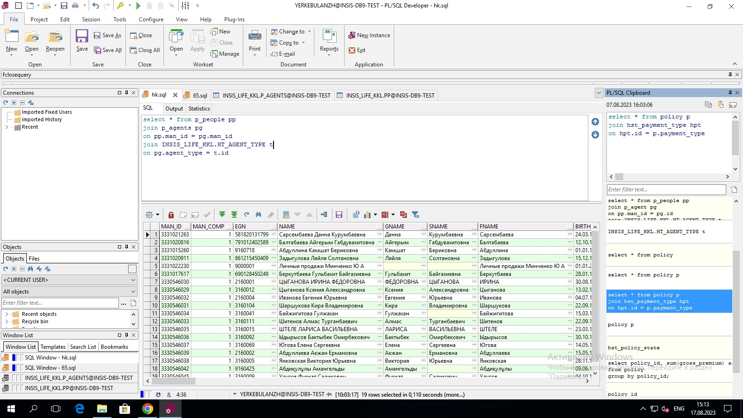

Oracle Analytics is a powerful data analysis and visualization tool developed by Oracle Corporation. It is designed for a variety of purposes and helps organizations make more informed business decisions.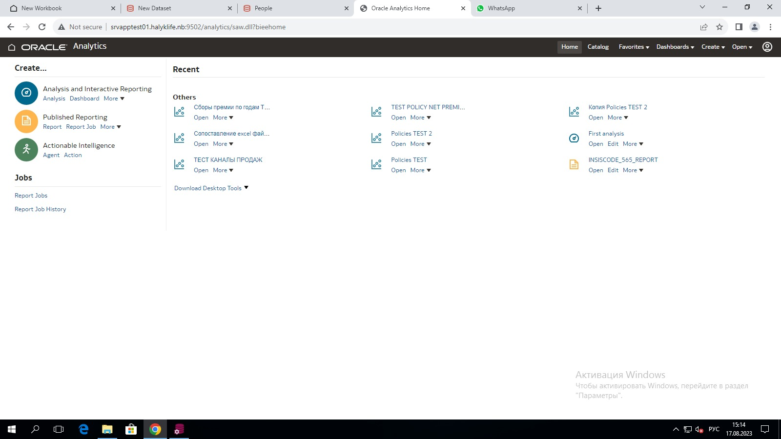

Examples of one of my queries and visualizations from Oracle Analytics program.

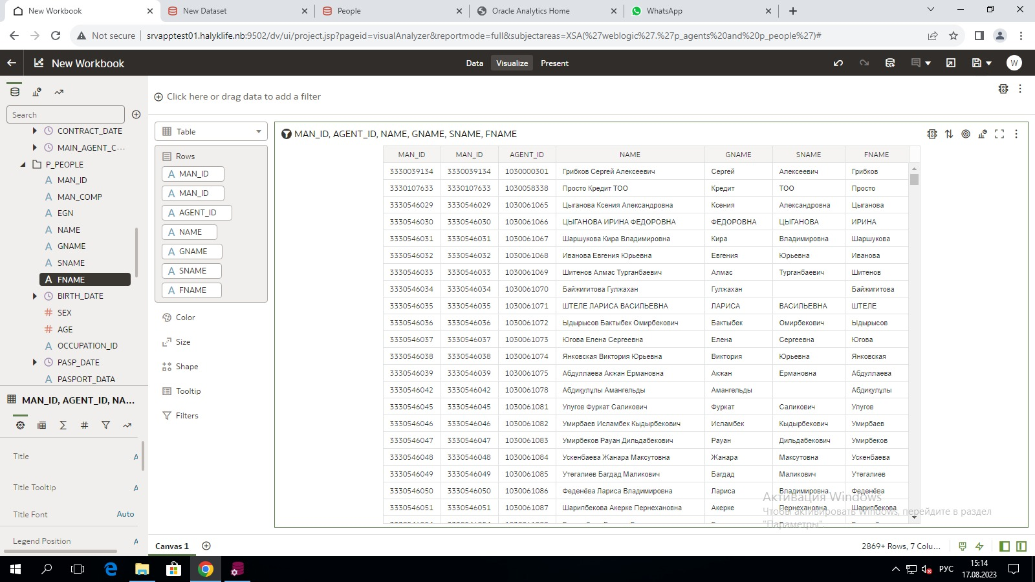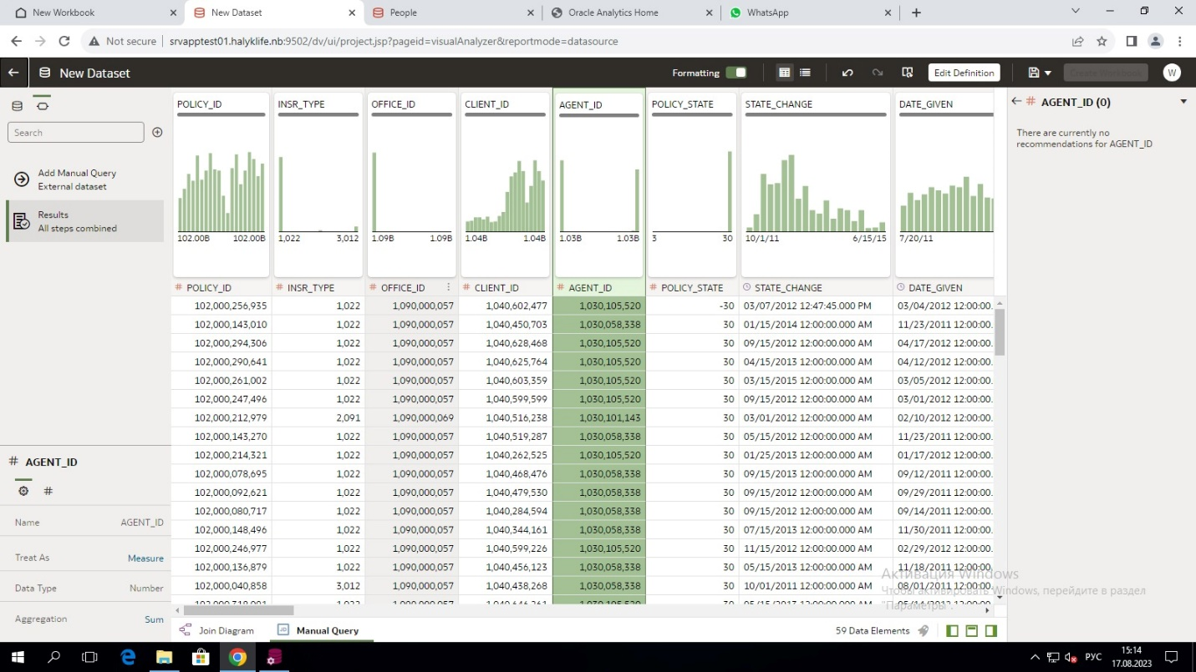

I presented each report result to my supervisor and received an evaluation.

# **Conclusions**

During the internship, I acquired practical skills and abilities that will be essential for my future career. These skills and abilities were gained through direct participation in the organization's activities.

Upon completing the internship, I have acquired skills in effectively using personal computer software and in independently solving practical tasks. This experience has led to the organization and consolidation of theoretical knowledge, further solidifying the knowledge, skills, and abilities acquired during my theoretical training in practical application.

This internship has provided valuable practical experience for my future endeavors. Throughout the duration of the internship, I encountered new and interesting facts, reinforced my theoretical knowledge, gained a deeper understanding of my profession, and this experience will serve as a solid stepping stone in my future career path.

# **Offers**

As a future specialist, I propose:

* Private Wi-Fi: Adding a private Wi-Fi network for employees to ensure a secure and efficient internet connection.
* Recreational Space: Establishing a dedicated area for relaxation and entertainment, such as a break room or lounge, to promote employee well-being and work-life balance.
* Employee Benefits: Introducing additional benefits like access to a gym, dental care services, and other perks to enhance the overall job satisfaction and health of employees.

# **Bibilography**

1. Фейерштейн С., Прибыл Б. Oracle PL/SQL. Для профессионалов. 6-е изд. — СПб.: Питер, 2015. – 36 с.
2. Edward R., Tracy M., Glenn S., Robert G., Look Smarter Than You Are with Oracle Analytics Cloud Standard Edition, First Edition, 2017. – 50 p.
3. Алан Б., Изучаем SQL. 2-е изд. – СПб.: Симбо, 2007
4. Орлов С.А., Цилькер Б.Я. Технологии разработки программного

обеспечения: Современный курс по программной инженерии, 4-е издание: Учебник для вузов – СПб: «Питер», 2012. – 608 с.

1. https://www.halyklife.kz/about/press_center/corporate_newsletter